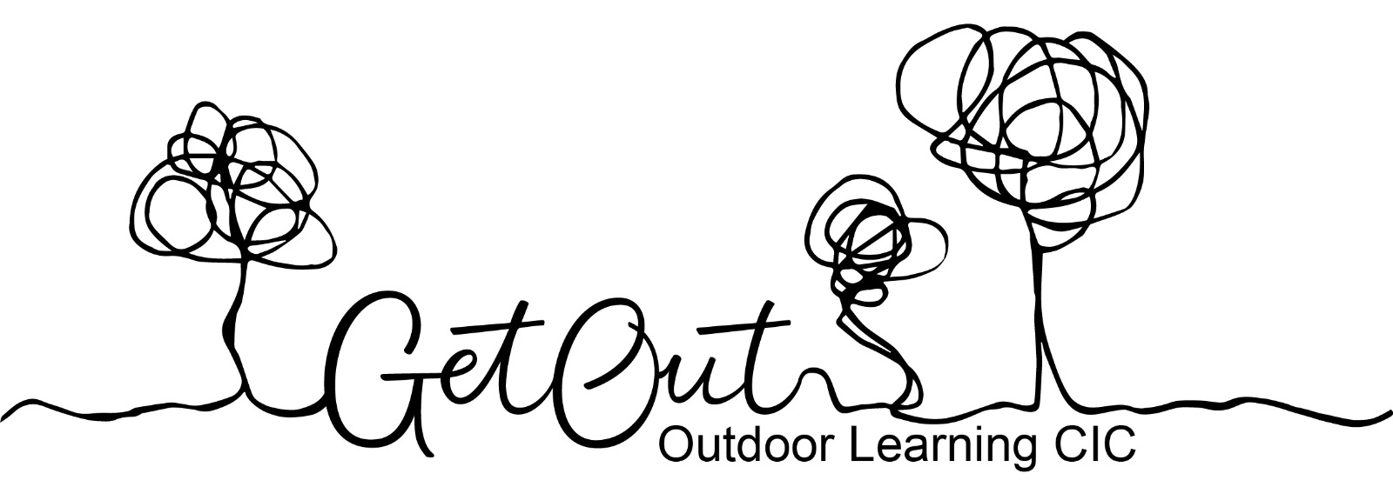

**Environmental Policy**

At GetOut, caring for our local, national and international environment is at the heart of what we do. We are highly aware of our environmental responsibility as a growing organisation and endeavor to approach our work in the most environmentally sensitive way possible. The impact of Forest School on sites which are used regularly throughout the year needs to be carefully monitored.

**Permission**

* Bearing in mind the Scottish Outdoor Access Code (SOAC), GetOut will always ask landowner’s permission before using a woodland site for Forest School but in particular before lighting a fire.

**Denudation**

* The removal or reduction of woodland resources for activities could have a detrimental effect on the ecology of the area.
* To avoid this, learners are reminded of the rule - 1 in 20, i.e. only to pick a flower/ leaf/fruiting body etc if there are plenty.
* Forest School leaders will provide wood for fires to ensure no habitat is destroyed by the burning of deadwood.

**Compaction**

* The continuous use of an area over time can lead to compaction of the soil which has a deleterious effect on its structure and restricts plant growth.
* Forest School will monitor impact on regularly used sites by taking pictures at the start and end of a Forest School term.
* The Forest School site will be surveyed annually, working with landowners, to assess if Forest School is adversely affecting this part of the woodland from overuse. If this is found to be the case, we will help identify another site that could be used in rotation.

**Pollution**

* Any litter from groups e.g. snack wrappers are collected in a black bag and removed.
* Forest School leaders will empty the chemical/sawdust toilet off-site at the end of a session.
* Paper waste is put in a lidded bin next to the toilet and the bag from this is emptied into the main site bin bag at the end of each session and sealed and disposed in a bin off-site.
* Any other liquid waste such as unwanted hot drinks should be removed from the site at the end of a session and emptied down a drain at home.

**Corruption**

* Care should be taken to ensure that noise does not cause unnecessary disturbance to local residents or protected wildlife i.e. badgers.
* Care should be taken with tools and clothing to prevent the spread of invasive or non-native species.
* Any leftover food should be removed from the FS site and either put in food recycling if waste, or stored/transported appropriately and used again if absolutely safe to do so.
* Un-drunk hot chocolate and other hot drinks will be poured into a basin and taken away at the end of the session.

**Environmental Choices**

* Wherever possible, the Forest School will make environmentally sensitive choices e.g. environmentally friendly cleaning chemicals for the toilet, kiln dry clay as opposed to air dry clay due to plastic fibres in it.
* GetOut team will car share wherever possible for meetings etc.